**Ideation Phase**

**Empathize & Discover**

|  |  |
| --- | --- |
| Date | 31 October 2025 |
| Team ID | NM2025TMID08347 |
| Project Name | Laptop Request Catalog Item |
| Maximum Marks | 4 Marks |

**Empathy Map Canvas:**

An empathy map for the Laptop Request Catalog Item focuses on the employee experience when requesting laptops an empathy map helps visualize what users say, think, do, and feel. It provides a deeper understanding of the user's needs and frustrations to guide solution design.  
Below is the empathy map for the Service Catalog laptop request scenario.

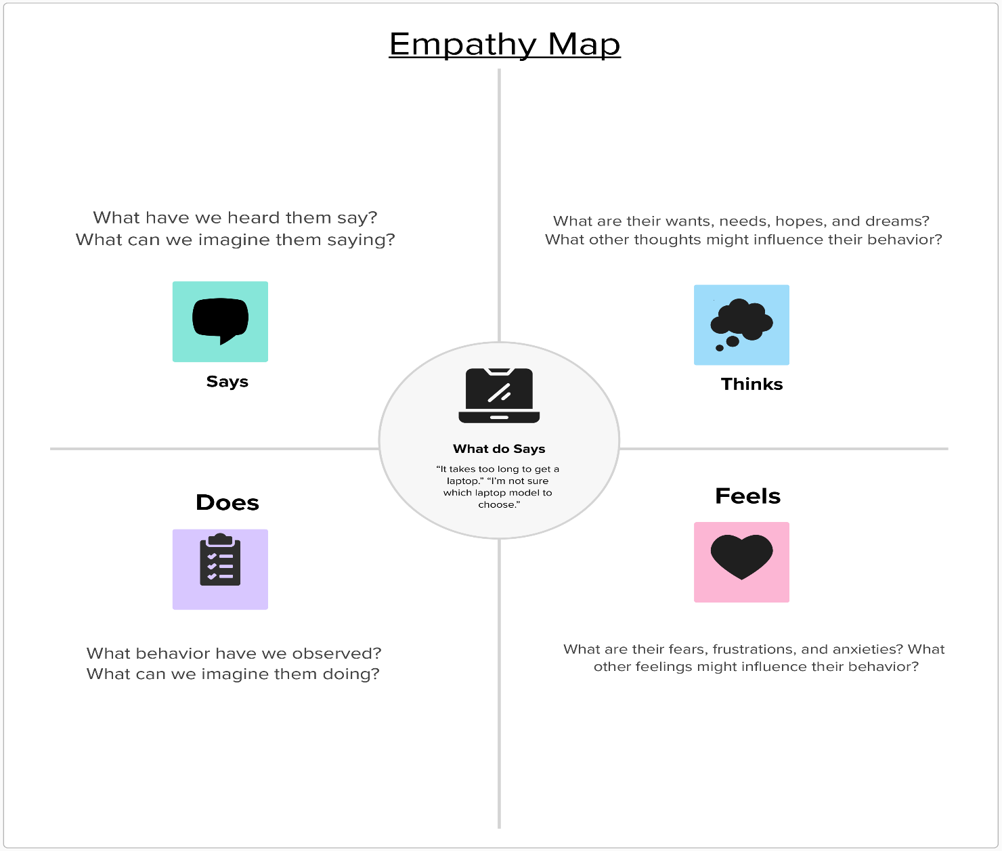

Reference: <https://www.mural.co/templates/empathy-map-canvas>

**Laptop Service Catalog Item**

